**Pass task 7.1 Sprint Retrospective**

**Meeting Agenda**

Date/Location: 25-April-2019 at 2:00PM in A302

**Sprint Review**

* Added an easy AI mode by AC
* Added mute button by Marc
* Added reset button by LL and change the colour of the AI
* AC fixed the bug where ships deployed will be a few square above the mouse cursor
* AC fixed the bug where the ship is not able to deploy in a vertical position
* Product owner was satisfied with the easy AI mode, mute button, and reset button after the presentation
* Product owner said highscore is not stored in the txt file so that needs to be fixed. She also said to add two more extention during the upcoming sprint week

**Sprint Retrospective**

* After a lot of attempts, we managed to make the battleship run
* Everyone attended the scrum meeting
* Manage to overcome all the problems encountered
* Make the shots taken by both the AI and player more distinctive
* The font of the game needs to be enlarged to increase the visibility.
* The UI of the game has to be improved on to better improve upon the aesthetics
* Fix the cooridnate bug
* Add an instruction page to help user understand how to play
* The highscore did not record into the txt file so that needs fixing
* AC had his wisdom tooth removed during the sprint week so it was not a good week for himk
* Everyone had other responsibilities and assignments to do so the air around the team is tense

**Information Updates/Reminders**

* Last week was about adding the extensions and documenting the code
* This week we will do a sprint review of our product and process and also continue adding in any extensions or game bugs that are not done yet
* Help from an external consultant has been provided to help get the code converted and working if that was not done.
* Everyone should have used toggl.com to track their time last week. Also track time on tasks this week with Toggl.
* Tutor must be added to GitHub, Trello and Toggl.
* Slack will be used to show the changes in the Trello board during the sprint of activity
* The Programming Help Desk ATC620 is *still* available to help us with programming for this unit.

**Decisions Needed**

* Solving the leftover known game bugs
* Implement the extensions that re not implemented yet
* Fix some functionality issues with the extensions implemented
* Fix the the issue where the high score is not saved and not outputted to the highscore.txt file.
* Improve upon the UI of the game

**General Items**

* The Trello board needs to be updated ready for the planned Sprint process. In particular columns for project backlog and sprint backlog will be needed.
* Create and link the team slack so that we can be notified and have a nice record of the Trello updates.
* The project backlog of tasks needs to be created. Use the existing bugs and features we have documented, and convert to the required format. Need a meeting after this meeting to get that done and into Trello (today).
* Project backlog tasks need to be prioritised and their time estimated using 1,2,4,8 hour categories. (Today)
* The new Sprint backlog needs to be pre-selected ready for discussion and approval with the project owner. (Today)
* Once Sprint has started, hold a daily scrum meeting. (Start next week?)
* Game bugs that exist from the previous week still need fixing
* Game functionality that is missing or not working from the previous week still need fixing as the program could not run
* Extensions will need to be improved upon and those that are not implemented yet to be implemented and also fix the functionality issues that come with it.

**Meeting Minutes**

Date/Location: 25/4/19 at Swinburne University of Technology in A302

Attendees: Marc Chai, Lim Jia Lok, Aldalton Choo

Start Time: [2:00 p.m.]

End Time: [3:30 p.m.]

**Decisions**

* AC will be fixing the highscore problem
* LL will fix the font of the game
* LL will improve upon the aesthetic of the game
* MC will fix the coordinate bug

**Actions**

* 1-5-19 AC should be done with fixing highscore probloem where the highscore is not saved upon quitting and not recorded in the highscfore.txt file.
* 1-5-19 LL should be done with improving the font design and size to increase the visibility.
* 1-5-19 LL should be done with improving aesthetic of the UI of the game to make it easier on the eyes.
* 1-5-19 MC will fix the coordinate bug that is causing the coordinate shown to be incorrect

**Scrum meeting**

Scrum meeting on the 26th April



Figure (1) Scrum meeting 10 on the 26th of April

Scrum meeting on the 29th April

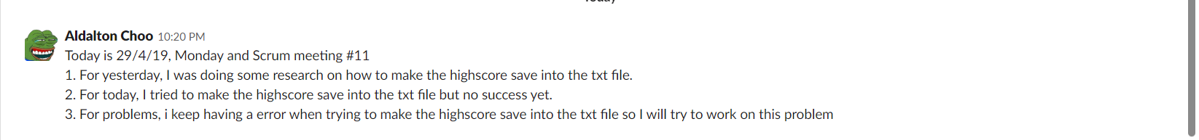

Figure (2) Scrum meeting 11 on the 29th of April

Scrum meeting on the 30th April

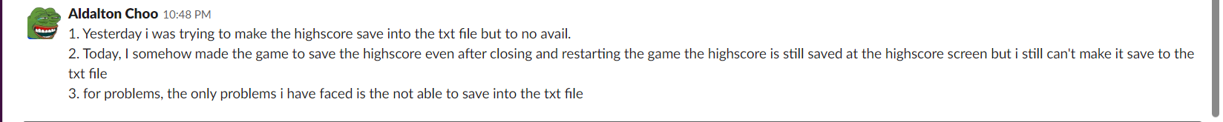

Figure (3) Scrum meeting 12 on the 30th of April

Making the highscore save in game:

In order to make the highscore save in game, I called the function HighScore() before the EndCurrentState() function in the HighScoreController. This made the highscore to be saved in the battleship game even after you exited the game the previous highscore is still shown after you restarted the game again. This can be seen in figure (4). While this works I still could not make the highscore save into the txt file even after numerous attemps.

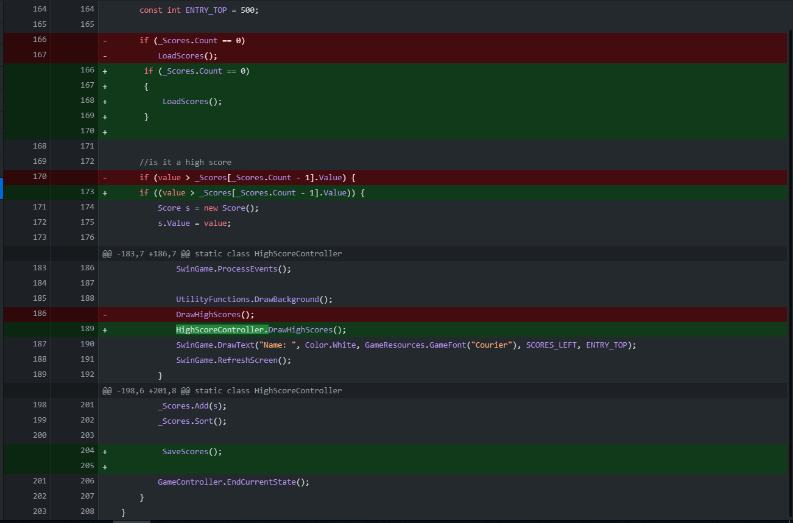

Figure (4) fixing saving high score in the game.

Trello Board

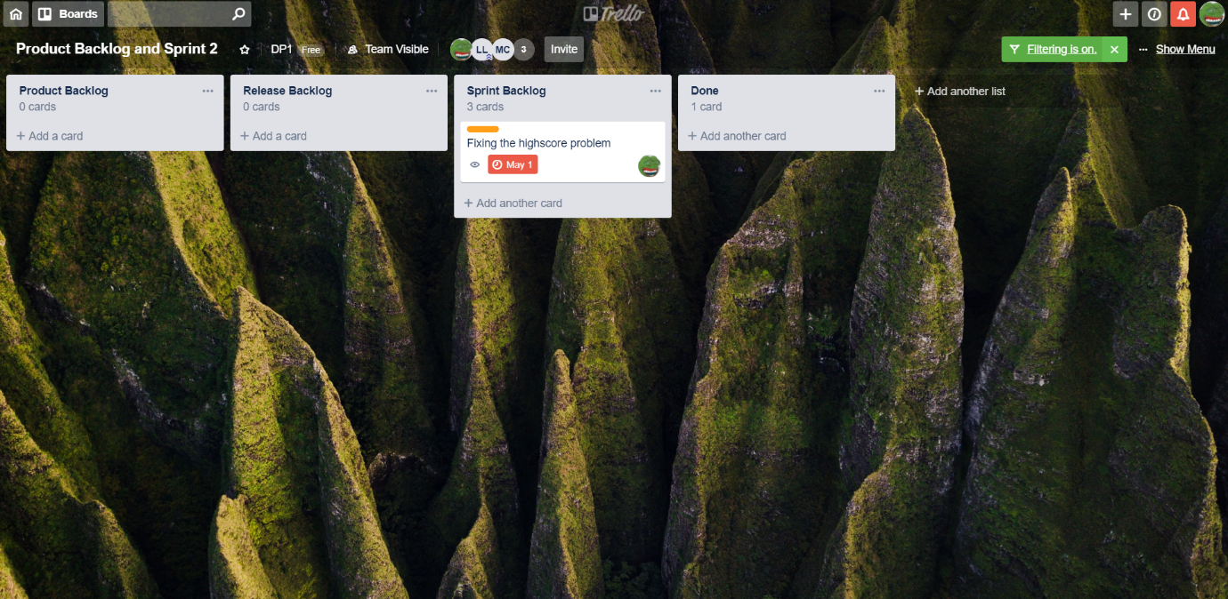

Figure (5) Trello Board

Toggl Board

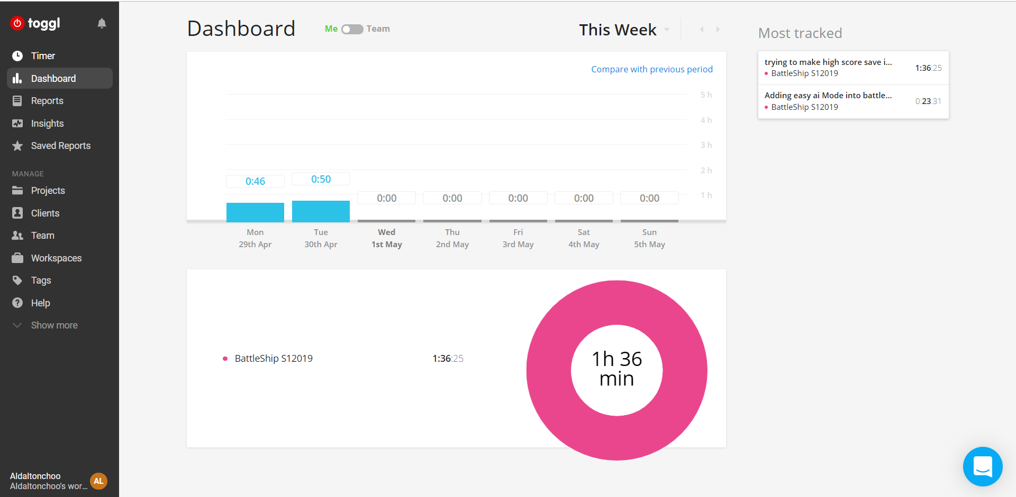

Figure (6) Toggl Board

GitHub Contributors and Network graph

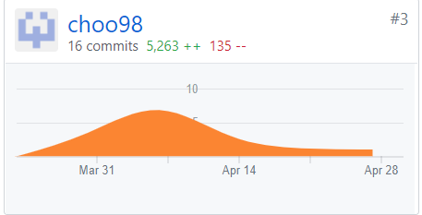

Figure (7) Contributor graph

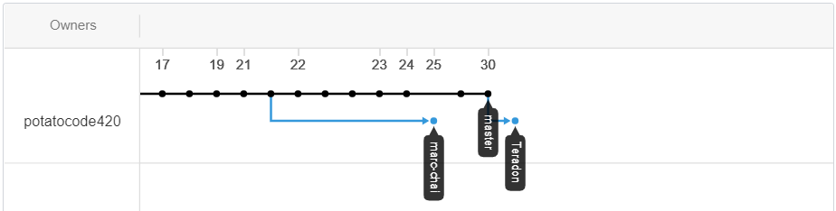

Figure (8) Network graph